TABLES USED IN DATABASE:

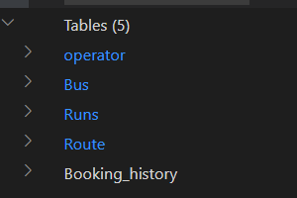

Operator Details along with sample input:

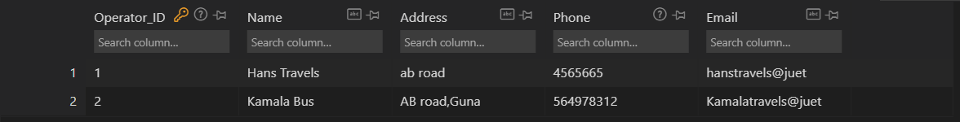

Bus details with sample inputs:

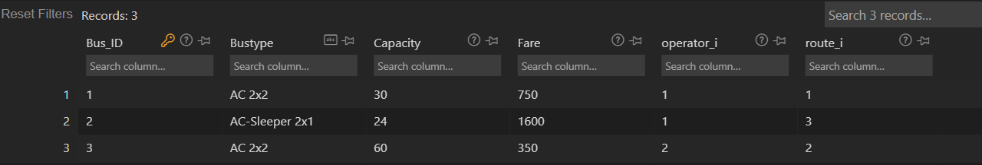

Runs details along with sample inputs:

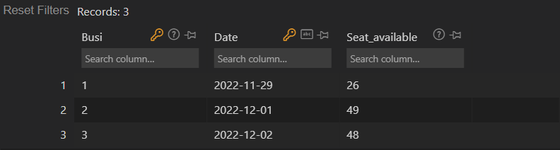

Routes detail along with sample inputs:

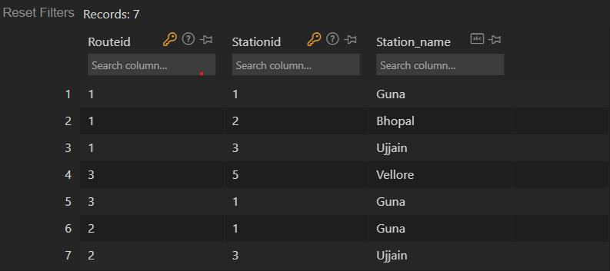

Passenger details along with some sample bookings:

